

**School of Computer Science Engineering (SCOPE)**

**B. Tech – Computer Science and Engineering**

**Project Title:**

**E-Commerce Promoting Small Businesses**

**Course Code: BCSE203E**

**Course Title: Web Programming**

**Class Number: CH2024250501655**

**Semester: Winter 2024-25**

**Slot: E2**

**Team Members:**

**Lavisha Keshwani 23BCE1507**

**Harshita Kumari 23BCE1478**

**Course Faculty:**

**Dr. L.M. Jenila Livingston**

1. **Abstract**

In today’s digital age, small businesses face significant challenges in establishing a strong online presence. Many local vendors struggle with limited reach, high advertising costs, and a lack of digital literacy. Our **Small Business Marketplace** aims to bridge this gap by offering a **user-friendly platform** that allows small businesses to register, showcase their products, and connect with potential buyers.

The platform includes:

* **Business Registration & Authentication** – A streamlined process for vendors to create and manage accounts securely.
* **Product Listing & Filtering** – Allowing businesses to upload product details, categorize items, and enhance visibility.
* **Real-Time Search & Ranking** – Using an interactive search system to help buyers find relevant businesses.
* **Modern UI/UX Design** – Featuring Bootstrap, JavaScript animations, and CSS effects for a seamless experience.

By integrating **interactive elements, business rankings, and seller engagement tools**, this project provides a **comprehensive e-commerce solution for small businesses**.

1. **Video Presentation**

Link- <https://drive.google.com/file/d/1I4uNuPWF6kYClGErui-Ahh2TSbeL0xor/view?usp=sharing>

1. **Introduction**

E-commerce has revolutionized the global marketplace, yet **many small businesses remain underserved** due to:  
🔹 **High competition from large brands**  
🔹 **Limited financial resources for marketing**  
🔹 **Lack of digital awareness & adoption**

Our **SmallBiz Marketplace** addresses these issues by creating an **affordable, scalable, and easy-to-use platform**.

**Core functionalities include:**

* **Business onboarding** – Hassle-free registration for sellers.
* **Product showcasing** – A visually appealing and interactive catalog for products.
* **Customer engagement tools** – Chat support, real-time product filtering, and trending business highlights.
* **Marketing & Branding Features** – Helping small businesses enhance their **brand visibility** through interactive banners and promotions.

This project integrates **HTML, CSS, JavaScript, Bootstrap**, and backend services like **Node.js and MongoDB** to ensure a **dynamic and engaging** online marketplace.

1. **Project Motive**

The core motivation behind this project is to:

* **Empower small businesses** by providing an easy-to-use e-commerce platform.
* **Enhance product visibility** through engaging UI and interactive features.
* **Boost customer engagement** with real-time search, filters, and business rankings.
* **Ensure seamless transactions** with user authentication and smooth navigation.
* **Create a scalable solution** that can be expanded with additional business tools.

1. **Challenges faced during design and implementation**

During development, we encountered several technical and design-related challenges:

* **User Experience (UX) Design** – Ensuring an intuitive and visually appealing interface without overwhelming users.
* **Data Management** – Handling product data, business information, and customer interactions efficiently.
* **UI Responsiveness** – Optimizing the website for seamless mobile and desktop experiences.
* **Performance Optimization** – Reducing load times through image compression, lazy loading, and CDN integration.
* **Authentication & Security** – Implementing **OTP-based verification** for secure user registration.

By implementing **modular development** and following **agile methodologies**, we successfully overcame these challenges while maintaining **scalability and performance**.

1. **Software Specification**

* **Frontend:** HTML, CSS, JavaScript, Bootstrap
* **Backend:** Node.js, Express.js
* **Database:** MongoDB (for storing business and user data)
* **APIs:** Google Firebase (for OTP authentication)
* **Hosting:** AWS/GCP/Azure
* **Version Control:** GitHub

1. **Modules**

The platform is structured into **seven key modules**:

1. **User Authentication**

* Secure **login & signup** for customers and sellers.
* OTP-based verification for secure access.

**2. Business Registration**

* Allows sellers to create a profile with **business name, contact details, and product categories**.
* Businesses go through an **approval process** for verification.

**3. Product Listing & Showcase**

* Businesses can **upload products** with images, descriptions, and pricing.
* Customers can browse and filter products by **category, price, and availability**.

**4. Search & Filtering System**

* Real-time **search functionality** to help customers find relevant products.
* Advanced **filters for location, category, and price**.

**5. Top Businesses & Bestselling Products**

* A **ranking system** highlights top-performing businesses based on sales and engagement.
* **Trending products** section showcases the most popular items.

**6. Marketing & Engagement**

* **Promotional banners, sliders, and seasonal discounts** to boost sales.
* Features to highlight **featured businesses and new arrivals**.

**7. Future Scope - Secure Payments**

* Integration with **UPI, credit/debit cards, and digital wallets**.
* **Order tracking system** for seamless transactions.

1. **UI Design for Modules**

The platform has a **clean, modern UI** with **engaging elements**:

🔹 **Hero Section:** A **carousel slider** with animated text and interactive hover effects.  
🔹 **Business & Product Listings:** Structured product cards with **hover effects, zoom, and overlays**.  
🔹 **Registration & Login Forms:** Well-structured input fields with **OTP verification**.  
🔹 **Marketing Banners:** Animated flip cards and **parallax image effects** to attract users.  
🔹 **Footer Section:** Contains **contact details, quick links, and social media icons**.

The design follows a **dark and bottle green theme**, ensuring **modern appeal and visual consistency**.

1. **Results:**

Navigation bar and 5 sliders-

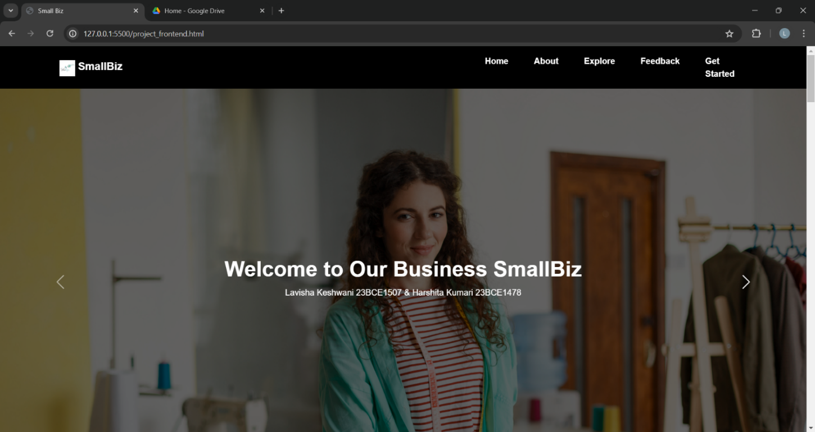

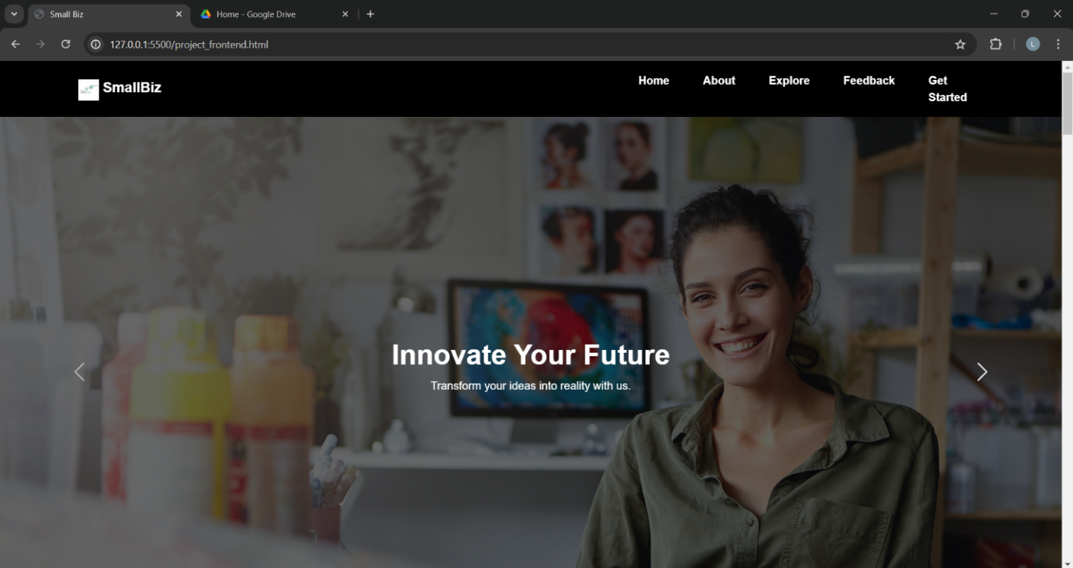

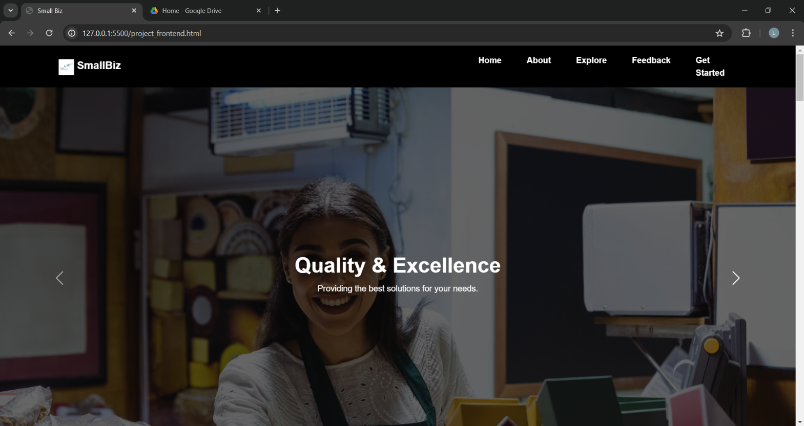

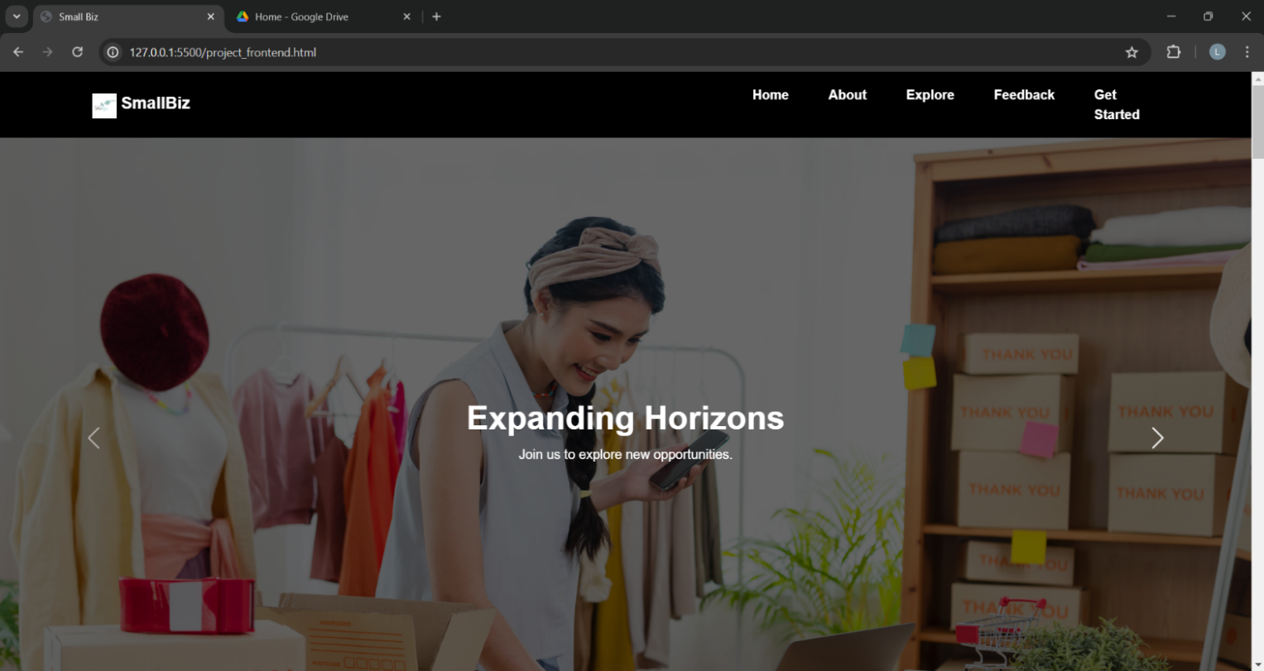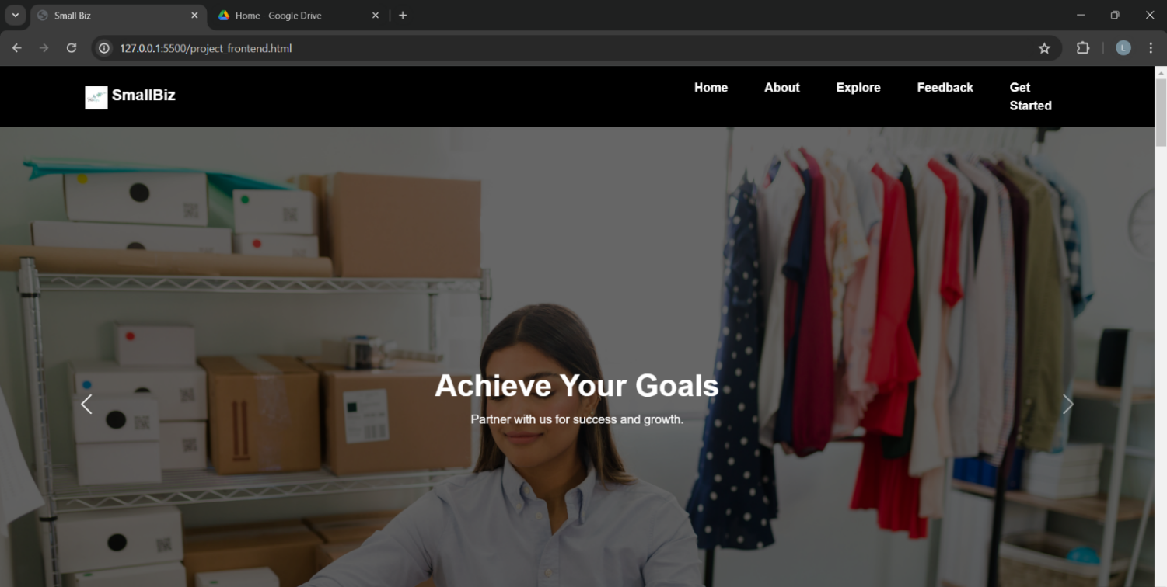

About Us section (rainbow gradient) and moving logos

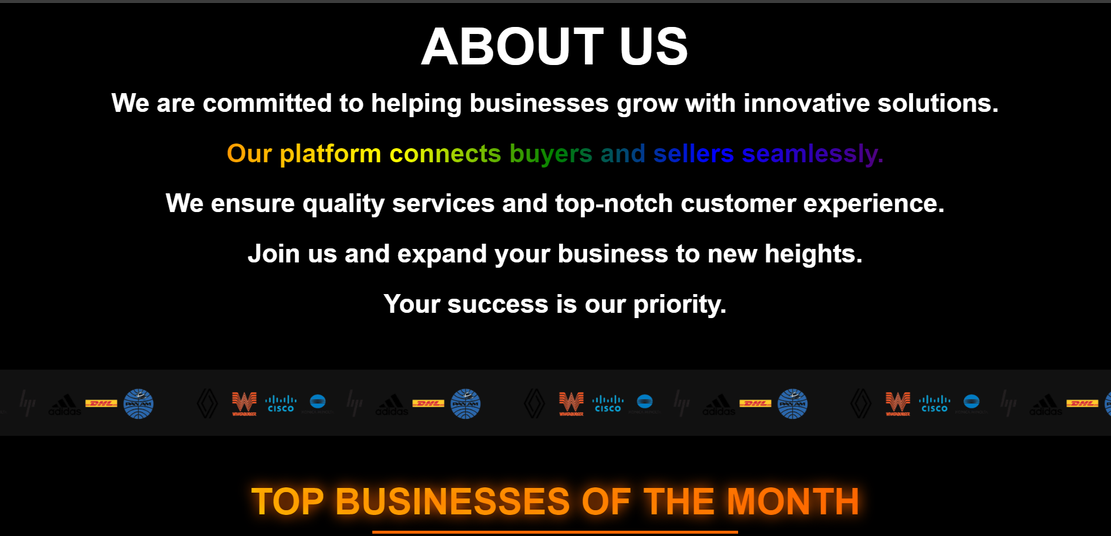

Analytics displayed and zoom in hover effect on images, also hover underline in heading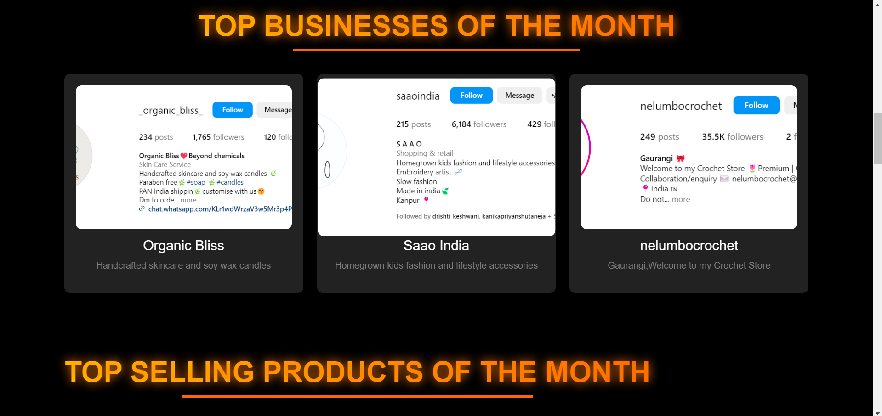

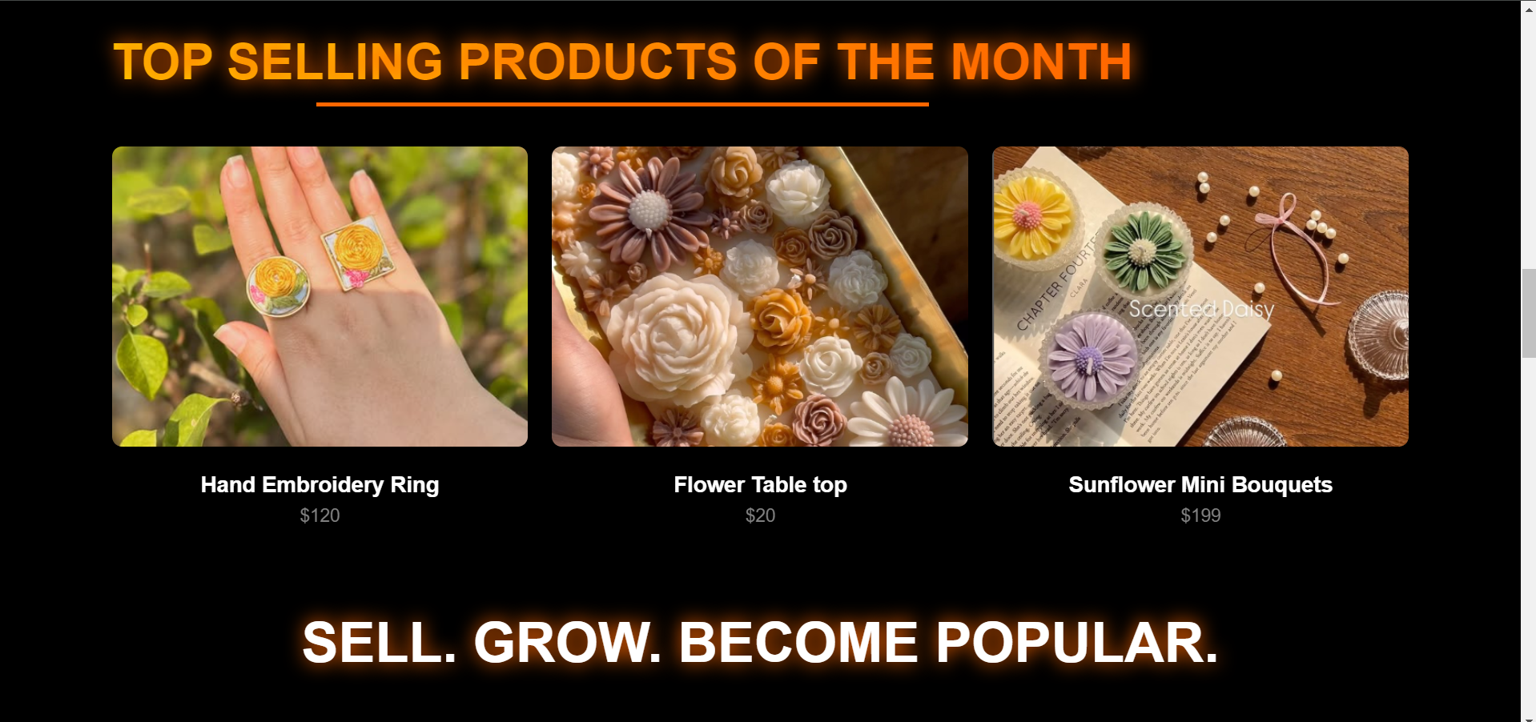

On hover green overlay comes which displays the business to which it belongs

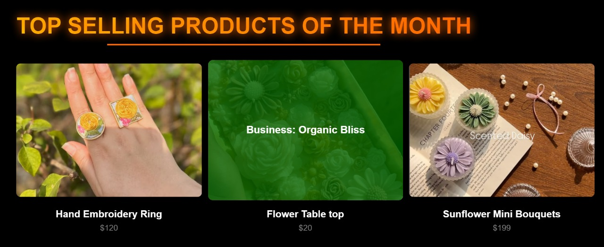

Promoting what our platform provides through images

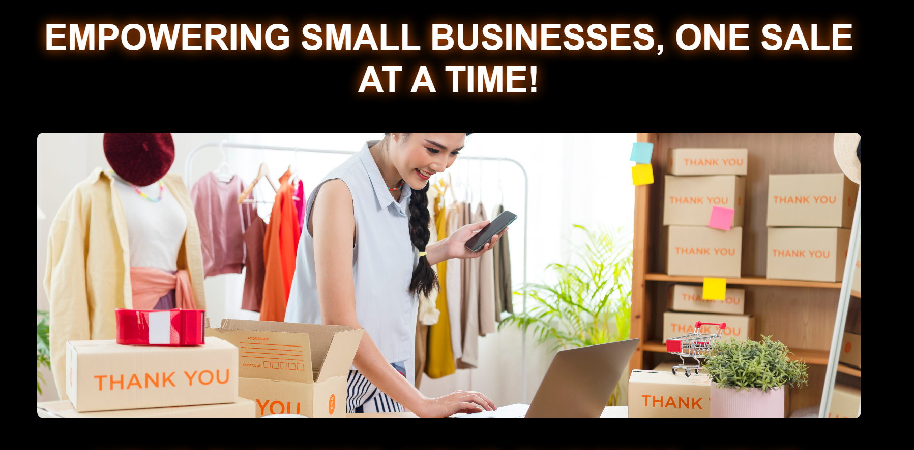



Flip cards used to display what benefits our platform provides, cards can rotate both clockwise and anticlockwise, different text present on both sides

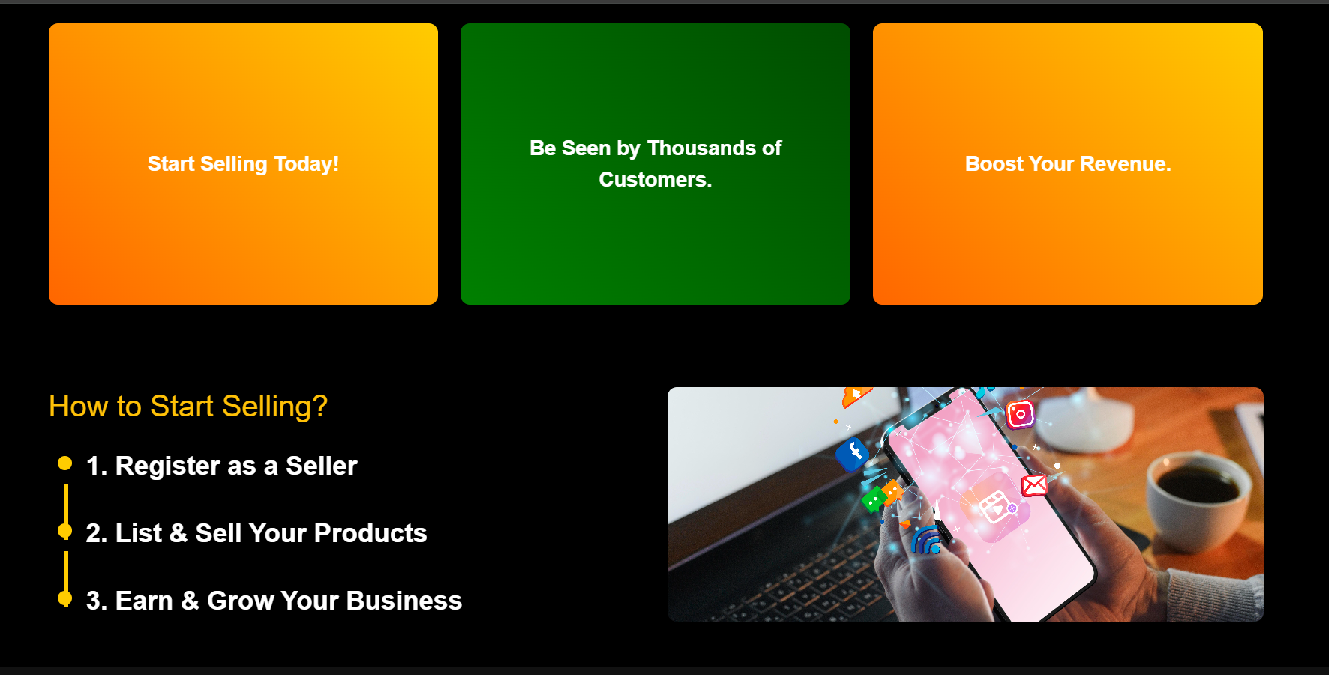

Steps mentioned on how to sell, these steps on hover zoom in, also the image changes as per the time set, then we follow up links and footer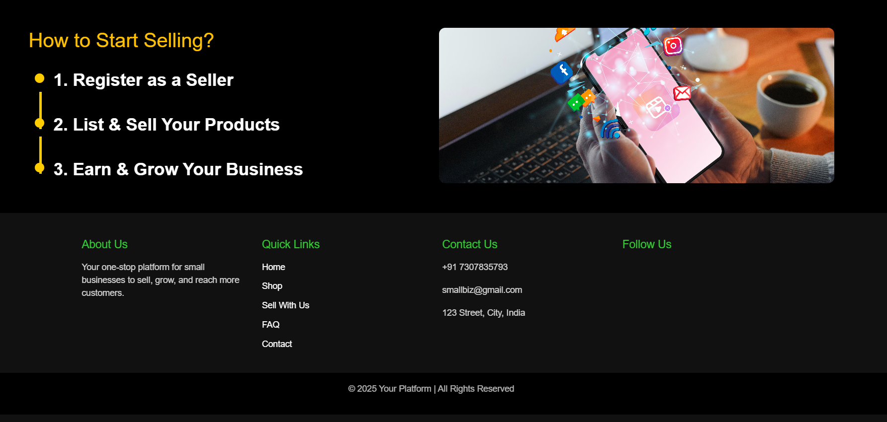

Sign In/ Sign Up page, sliders used wherein the division switches position if clicked on sign in

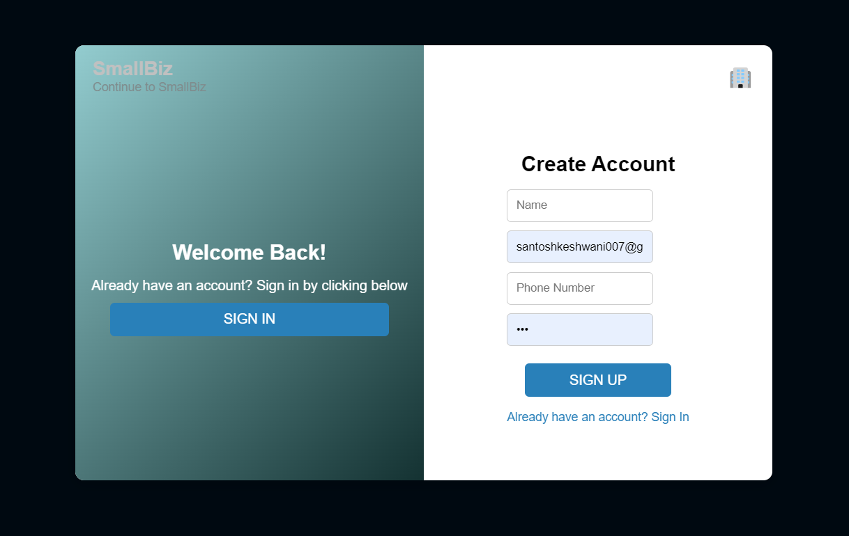

if incorrect mobile no or email id provided popup comes up

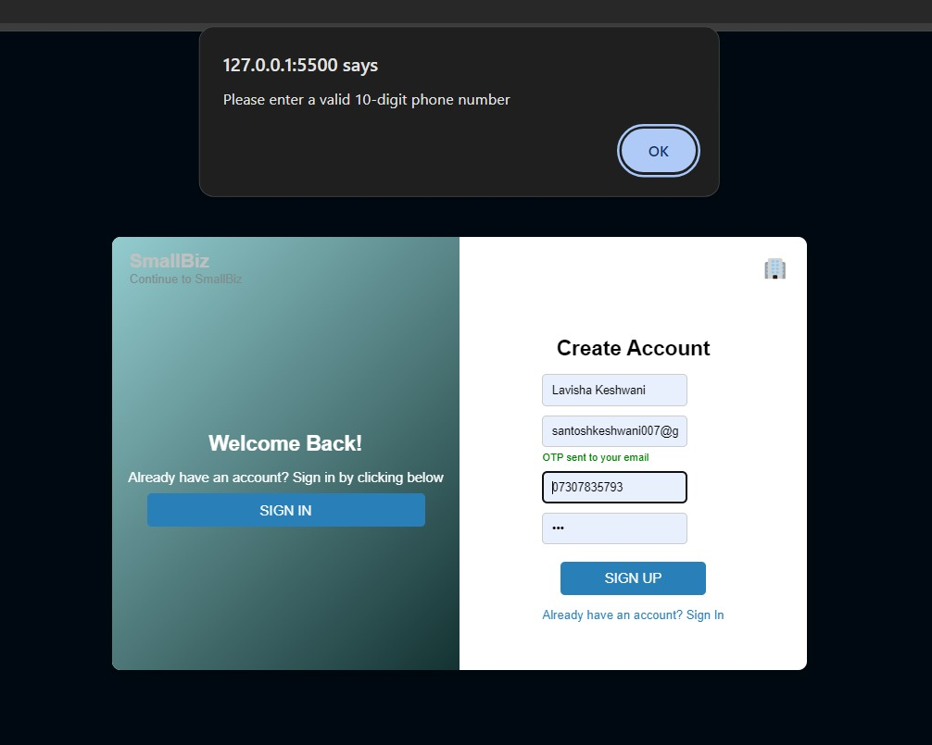

Sign in page, upon successful login redirects to home page

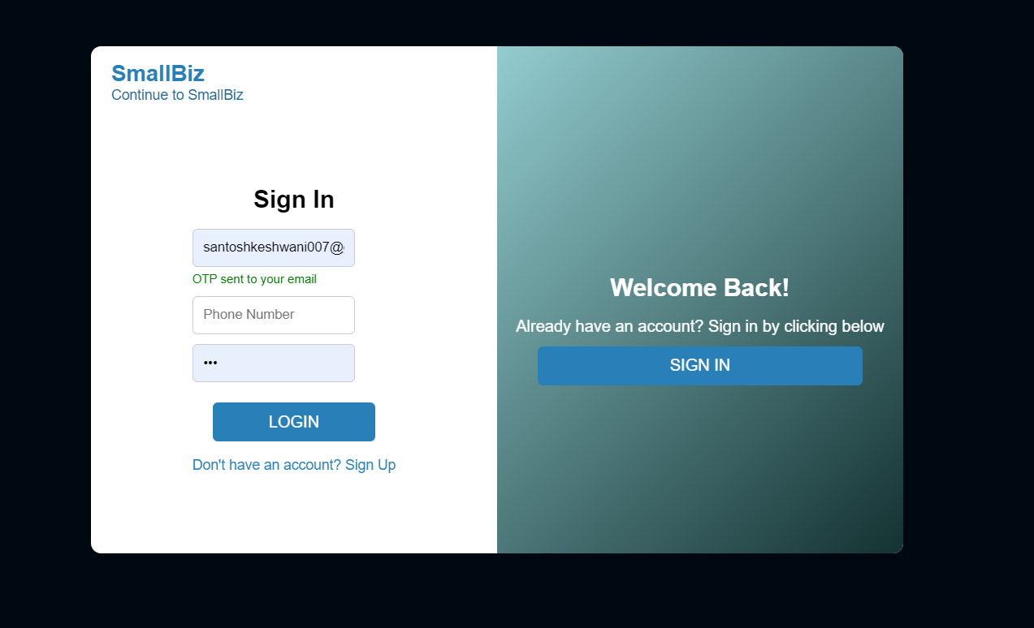

Explore page-neon text and below that a timer is present, different businesses listed as hyperlink, on clicking directs to that business in the page

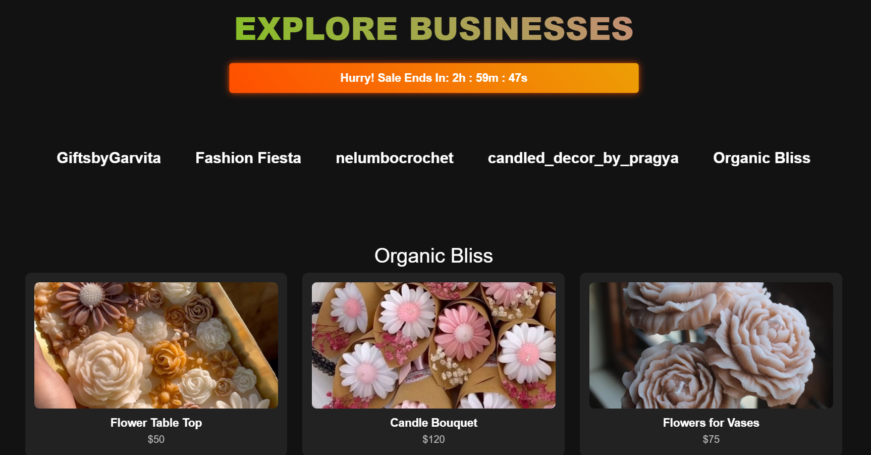

On hover becomes green and shows its tagline as well

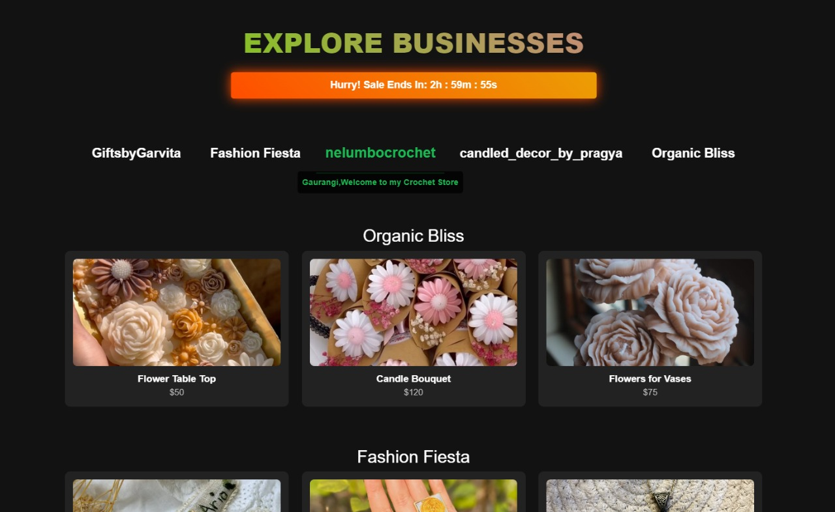

Different products of businesses listed, on hover image zooms in

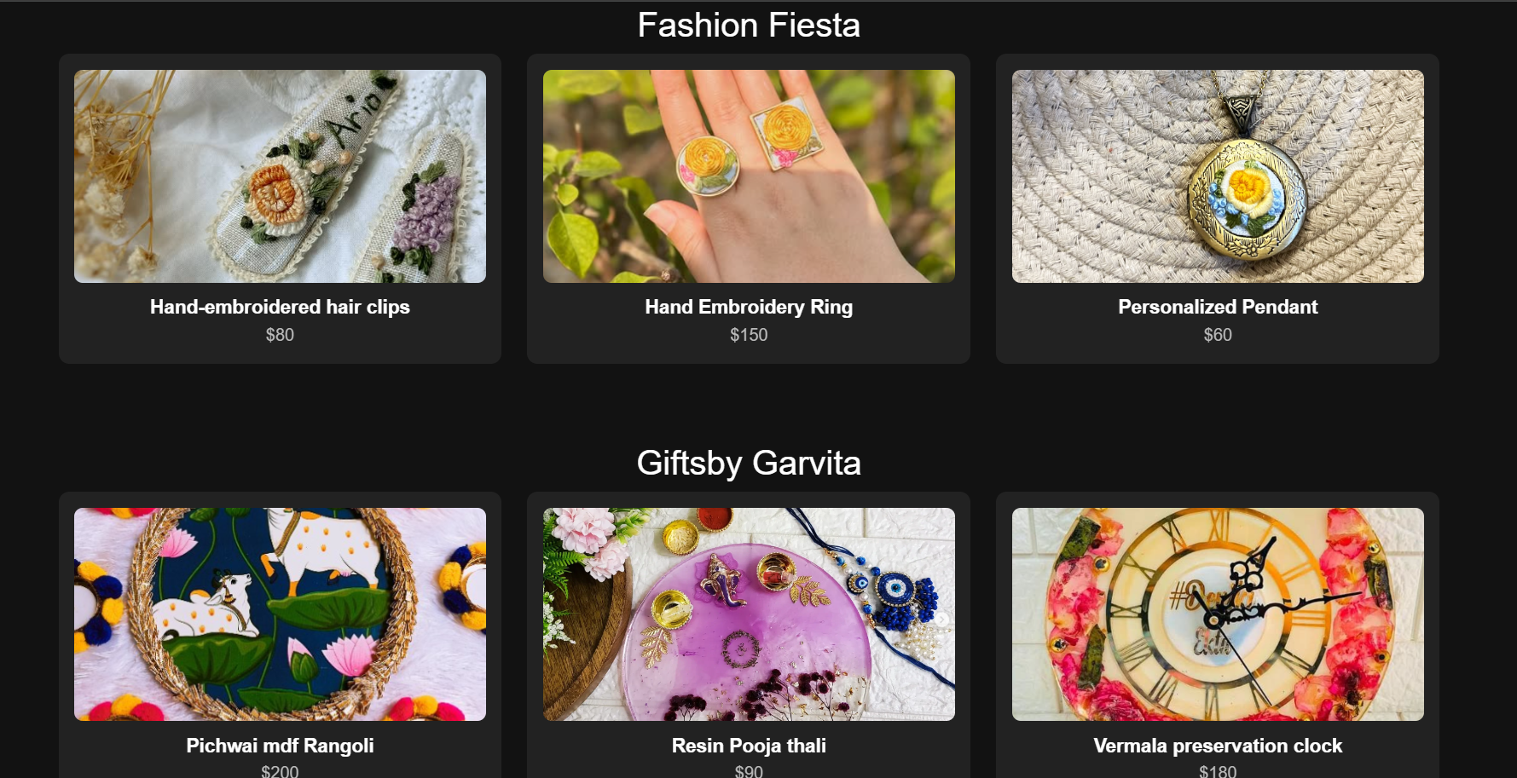

Feedback form- ‘we value your feedback’ is in animation (its text increase and decrease), on submit thank you message displayed

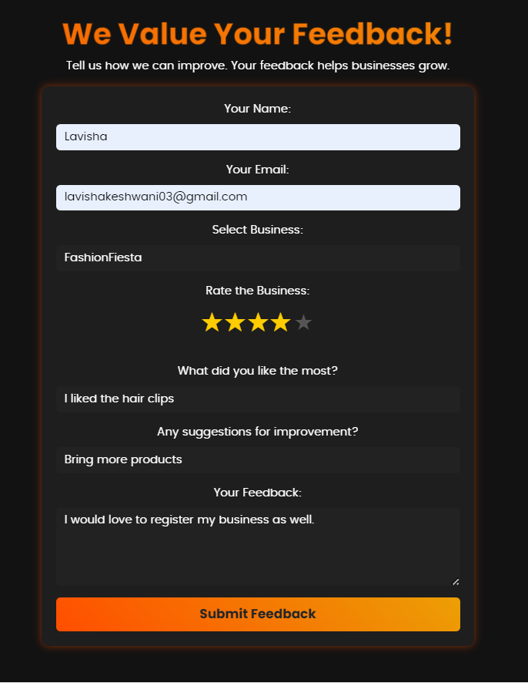

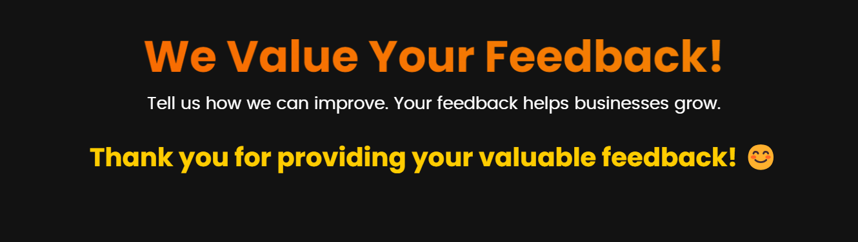

FAQ page- has navigation bar and footer, nav bar has hover green colour which is hyperlinked, the answers become visible when clicked on question, here also hover green effect applied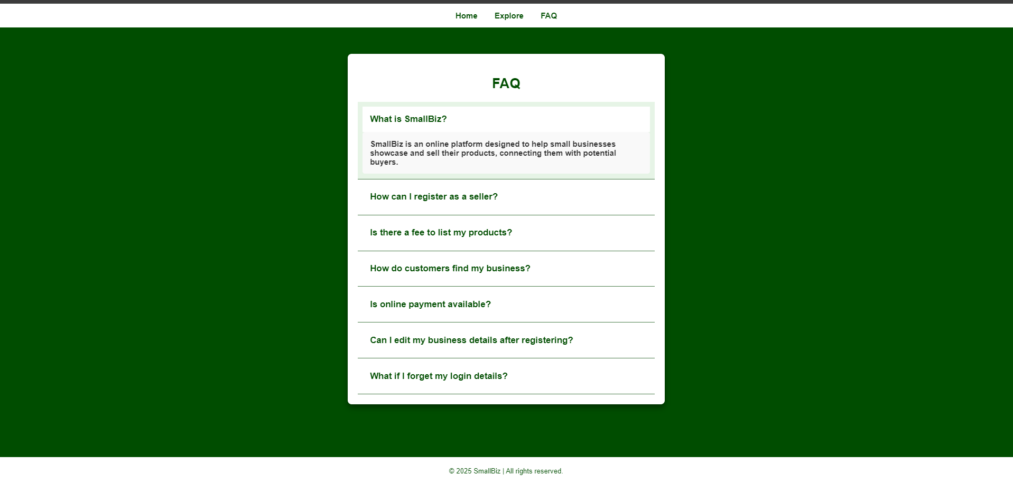

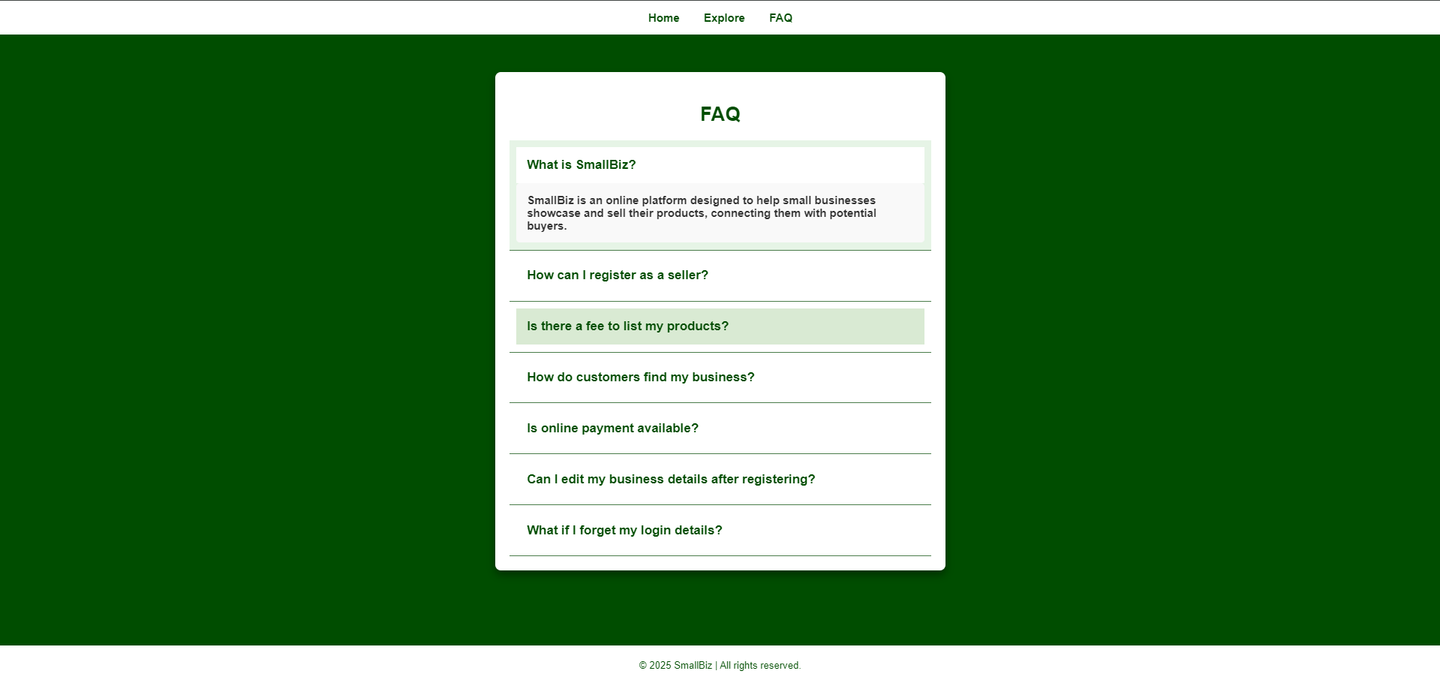

**10.Conclusion:**

This project provides **a user-friendly, scalable, and interactive e-commerce platform** that allows small businesses to grow online.

* 1. **Key Takeaways:**
* Empowering small businesses with an online presence.
* Providing a smooth and engaging user experience.
* Ensuring security and real-time interaction.
* Building a scalable and customizable platform for future improvements.
  1. **Future Enhancements:**
* AI-driven product recommendations for personalized shopping.
* Secure payment gateway integration for seamless transactions.
* Business analytics dashboards for sellers.
* Social media marketing tools to increase business reach.